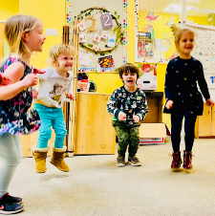
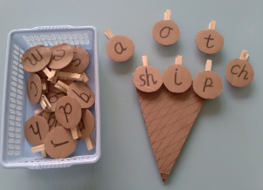
Phonics Progression
Rendlesham Primary School
At Rendlesham School, we believe in teaching high quality phonics as the prime approach to ensure all children become fluent readers and writers. We have a rigorous system of teaching phonics and early reading, developing our own phonics curriculum and assessment systems. It is for this reason that the school has chosen to not buy into a validated system as it has always historically achieved well in the national statutory tests in year 1 (see appendix 1).
Intent

To ensure that all children make progress and become confident and fluent readers and writers, and will be able to use their phonic knowledge to read and write at a standard at least equivalent to age related expectations.

To provide a consistent approach to the teaching of phonics – following a programme based on Letters and Sounds which has been adapted to ensure that the coverage and progression is clear and concise.

To provide high quality phonics teaching from all members of staff at Rendlesham, so they can support all children across the school.

Implementation
We have a whole staff approach to teaching phonics, all teachers and teaching assistants teach a small group of Key Stage 1 children and the year 3 children who did not pass the retake of phonic test in year 2. The year 1 and 2 children are grouped within the phonic phase they are working at, groups are small and can differ in size between individual (1:1) up to 1:8. The SEND children work in smaller groups and have differentiated targeted work to ensure that although they may not be working at age related expectations they do make progress. The children in year three work as a whole group and are taught by their class teacher during phonics, this helps with building links and closing gaps in knowledge during all lessons across the curriculum.

Planning is completed and resourced by the Key Stage 1 teachers and shared amongst the staff, it is based on the Letters and Sounds (2007) document. The Phonics Lead has adapted the document so all phoneme-graphemes are taught ready for the year 1 national statutory phonics test in the summer term. Rendlesham’s adapted scheme is not DFE validated as outcomes and pass rates for the year 1 phonic test is around the national standard. The daily teaching sessions introduce the main grapheme-phoneme correspondences of English in a defined and incremental sequence, progressing from simple to more complex. Phonic lessons follow the review, teach, practise and apply structure ensuring that children have the opportunity to blend and segment words and sentences. All plans follow this format, meaning that adults are familiar with the sequence of the phonic lesson and children know what is coming next.

The resources used in lessons: friezes, phoneme mats and flashcards are from a variety of sources – however they are consistent across EYFS, KS1 and KS2. The school’s reading books (all from different sources) have been organised and ordered into phonic phases and then into sets, these match the teaching sequence. The reading books are then used to support within the lessons so children have the opportunity to read longer passages practising the focus phoneme. For year 1 children the reading books go home at the level below the children are working in class, the texts are completely decodable so children can independently practise, experience success and learn to rely on phonic strategies. Once the children complete Phase 5 set 5, they will be issued with a reading book that is linked to the accelerated reader ZPD they are working within. The children who are in year 2 and still need to practise decoding skills will have a fully decodable phonic reading book, and a book linked to their accelerated reader level.

The assessment and tracking of how children move through the phonic phases is carefully monitored. It is the Key Stage 1 teachers that assess the children in their class. Assessment is based on knowing the phoneme and finding the grapheme and then being able to blend and segment the phoneme in words. Assessment occurs at the end of the phonic phase or the end of the set. The phonic groups are fluid and children can move freely through the phases depending on their needs. The phonic group leaders are responsible for communicating with Key Stage 1 teachers to give feedback on lessons and discuss the needs of children in their group.
Impact

All school staff have the knowledge and skills to teach phonics. Phonic CPD is on-going and targeted to ensure that staff are confident and proficient in each phonic phase – this links into the whole school CPD structure. The Phonic Lead monitors the lessons, and in particular the practise and apply parts of the planning, to ensure the maximum amount of time is spent with the children rehearsing the blending and segmenting skills needed.

The impact of this whole school teaching model for phonics has ensured that children are confident readers who are achieving above the national standard, after the impact of covid. Children have benefitted from working in smaller groups where they have more time with an adult to rehearse and practise blending and segmenting skills and can apply these to larger pieces of text. All staff are experienced in teaching phonics and using the vocabulary of phonics and are now able to support children with reading and will know the next steps for teaching reading.

The Teaching Sequence
Phase 1

Children begin their phonic learning in the Early Years Foundation Setting. In Nursery most phonic learning is based on Phase 1. Phase 1 concentrates on developing children’s speaking and listening skills and provides a good foundation for phonic work that starts in Phase 2. Phase 1 is split into seven aspects and consists of learning based on hearing sounds and differentiating between them through tuning into sounds (auditory discrimination), listening and remembering sounds (auditory memory and sequencing) and talking about sounds (developing vocabulary and language comprehension).

Aspect 1 is based on general sound discrimination (environmental sounds). It aims to raise children’s awareness of the sounds, around them both indoors and outdoors to develop listening skills. The activities could include: a listening walk, drumming on different surfaces and comparing sounds, playing a sounds lotto game or making shakers. These activities will help the children to differentiate between sounds in order to name and identify each sound correctly and discuss the differences between these sounds.

Aspect 2 is based on general sound discrimination (instrumental sounds). It aims to develop the children’s awareness of sounds made by various instruments and noise makers. Activities in the classroom could include: comparing and matching sound makers, playing instruments alongside a story and making loud and quiet sounds. The children will experiment with how they can change and affect the sound of the musical instrument and develop new skills such as following instructions to recreate a sound using an instrument.
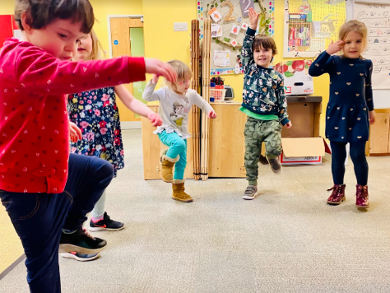
Aspect 3 is based on general sound discrimination (body percussion). It aims to develop the children’s awareness of sounds and rhythms through singing songs and action rhymes, listening to music and developing a sounds vocabulary. Children will be encouraged to join in with and copy body percussion sequences and later on recreate their own.

Aspect 4 is about rhythm and rhyme and develops the children’s appreciation and experiences of rhythm and thyme in speech. The children will be able to identify words that rhyme, they will explore breaking words into syllables and keeping a steady beat. Opportunities to play with rhyme and make their own rhyming words will be given.

Aspect 5 is based on alliteration. It focuses on initial sounds of words, and would include activities such as, I-spy games and matching objects that begin with the same sound. Children will be able to select objects that all begin with a certain sound and then later will be able to identify words that begin with the same sound. How sounds are articulated will be taught and practised.

Aspect 6 is based on voice sounds. Children learn to distinguish between different vocal sounds and mouth movements to begin oral blending and segmenting. Children are encouraged to talk about, describe and compare voice sounds. Activities could include creating voices for characters including animal sounds.

Aspect 7 is centred on oral blending and segmenting. The children develop oral blending and segmenting skills through a variety of games and activities, for example to practise oral blending the adult segments the CVC word and at first the child finds the objects from a group. To practise segmenting skills the adult could hold up the object and ask which sounds they can hear in the word.

By the end of Phase 1 all children will have had the opportunity to practise listening attentively, enlarge their vocabulary, speak confidently, discriminate different sounds including phonemes, reproduce audibly the phonemes they hear in words and orally segment words into phonemes. In Nursery all of the aspects from Phase 1 are carefully planned for and taught and continue to be woven into the EYFS curriculum. Phase 1 underpins the phonics programme and continues into Key Stage 1.
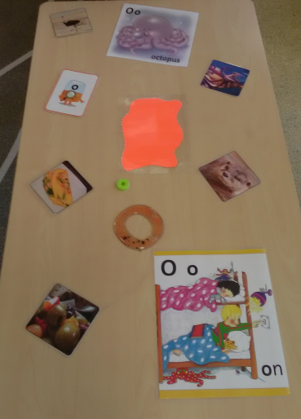
The children in Nursery have the opportunity to explore and engage with the phonic phoneme table practising to pronounce, draw, write and describe items starting with a particular sound.
This is an example of the phonic table used during continuous provision. During the summer term phonics is taught more explicitly to those children who are ready to be introduced to Phase 2.

Phase 2

As children progress into the Reception classes formal phonic lessons are daily. In September, the children learn together as a whole class, concentrating on one phoneme and grapheme each day within Phase 2 (see below). At the beginning of the year textless reading books are given to the children to share; interpreting pictures, making up stories, looking at characters and the settings etc. The children are able to build up their book knowledge and practise skills such as, holding the book and turning a single page one at a time. After the first set of letters are taught an assessment is carried out and then the children are split into groups according to their need. This is the first point that a reading book is given with CVC words that will be completely decodable, so children can practise their blending and segmenting skills using their knowledge of previously learnt graphemes. The sequential order is important as it allows for the most CVC words to be made once each sound is introduced. The children will have a visual point in the classroom to support them in their learning in reading and writing as after each grapheme is introduced it is added to the classroom display.
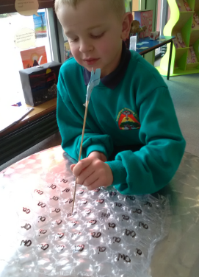
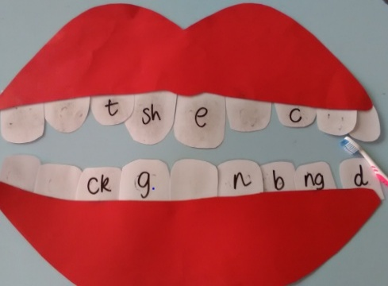
Both of these activities are examples of recognising graphemes by sound. These resources can be easily adapted to spell CVC words by orally segmenting or by recognising CEW words. These resources can be used in phases 2 to 5.

Phoneme | Common Exception Words | Reading Book Sets
SET 1  - s, a, t, p i, n, m, d  SET 2  - g, o, c, k, ck, e, u, r, h, b, f/ff, l/ll, ss | I, no, go, to, into | Each letter set has a group of books that uses the sound introduced so the book will be completely decodable.  Reception and KS1 have different sets of books for Phase 2 to allow for new reading if a child is not at expected level by the end of EYFS.

Phase 3

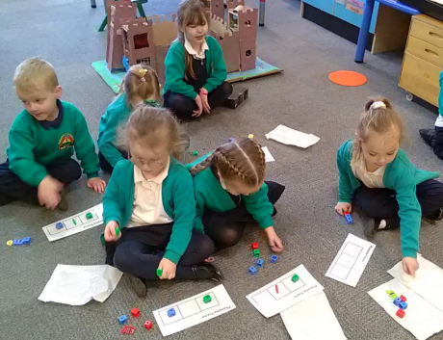
Once Phase 2 is embedded then Phase 3 will begin. In phase 3, digraphs and trigraphs are taught, this terminology is used and understood within the classroom. Children will continue in their groups to work at their pace through the letter sets. It is hoped that by the end of reception that most children will be at the end of phase 3 and will be confident in pronouncing, finding, writing, blending and segmenting each phoneme within words and short sentences.

By the end of EYFS Phase 3 will be embedded in the children’s learning as the Reading ELG defines children at the expected level of development will: say a sound for each letter in the alphabet and at least 10 digraphs, read words consistent with their phonic knowledge by sound blending and read aloud simple sentences and books that are consistent with their phonic knowledge, including some common exception words.

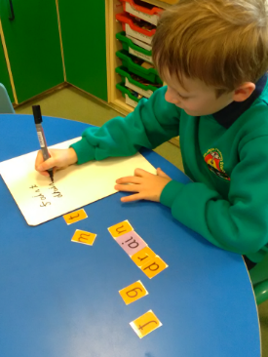
The range of resources: cards, phoneme frames and cubes are resources used to enable children to independently build and then blend to make words. It is also adaptable and allows children to explore different skills including rhyming and reading pseudo words.

Phoneme | Common Exception Words | Reading Book Sets
SET 1  - j, v, w, x, y, z, zz  SET 2  - ch, sh, th, ng, qu  SET 3  - ai, ee, igh, oa, oo, oo, ar, or, ur,  SET 4  - ow, oi, ear, air, ure, er | he, she, we, me, be, was, you, they, all, are, my, her | Each letter set has a group of books that uses the sound introduced so the book will be completely decodable.  Reception and KS1 have different sets of books for Phase 2 to allow for new reading if a child is not at expected level by the end of EYFS.

Phase 4
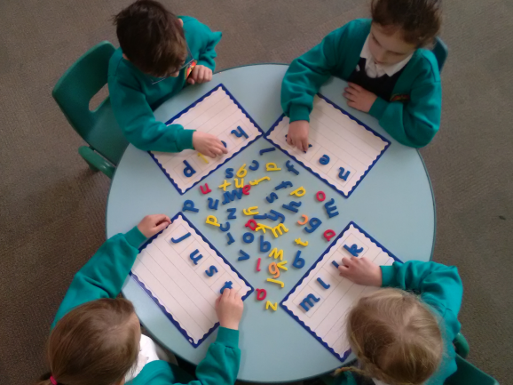
Once the children enter into Year 1, Phase 4 teaching will begin. In Phase 4 no new phonemes or graphemes are introduced. However, children will be taught to identify adjacent consonants in words and will practise reading longer words (polysyllabic). Phase 4 will take approximately 4 weeks to complete, however this may be longer depending on the embedding of the skills so children are confident to tackle and decode shorter and longer words. There is no set order to introducing the adjacent consonants in Phase 4, we would recommend that starting with CCVC and CVCC words and then CCVCC words. Children will be taught to ‘chunk’ words into syllables and read each part and then put together e.g. helpdesk would be help/desk.

- Phonemes as Phase 3 there are no new phonemes introduced in this phase | Common Exception Words  said, have, like, so, do, some, come, were, there, little, one, when, out, what | Reading Book Sets  Phase 4 books use the phonemes and graphemes introduced in Phase 3. They also have words that are decodable polysyllabic and that have adjacent consonants.
- Adjacent consonants | Beginning of words  bl, cl, fl, gl, pl, sl, br, dr, fr, gr, pr, tr, sk, sm, sn, so, st, sw, tw, spr, str, spl, | End of words  mp, nd, nk, nt, st, ft, ld, lp, lt, sk
- Polysyllabic word examples | helpdesk, pondweed, sandpit, windmill, softest, handstand, melting, helper, desktop, shampoo, giftbox, lunchbox,

Phase 5
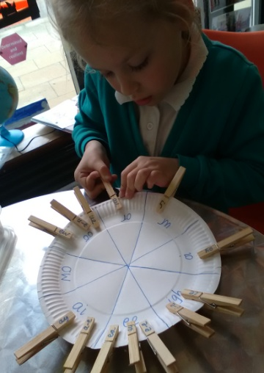
Within Phase 5 an alternative grapheme is introduced to those learned in Phase 3. At Rendlesham we have split the Phase 5 graphemes into 5 sets. In Phase 5 set 1, further digraphs that are still common and split digraphs are taught. In sets 2 to 5 within Phase 5 the graphemes increase in rarity and several alternative spellings for each graphemes are introduced. The graphemes have been sorted in this way as it has enabled clear identification for resources and reading books to be matched to the grapheme. Rendlesham School does not have a set reading book scheme and has over the years collected sets of books from various reading schemes. These have been sorted into each set (see below) so the children are still able to take home a decodable book and practise their blending and segmenting skills.

Phase 5 SET 1 – Year 1
Phoneme | Common Exception Words | Reading Book Sets – Example Texts
- ay, ea, ie, ey, ew, ew, ue, ue, oy, ou, oe, ir, wh, ph, aw, au, a-e, e-e, i-e, o-e, u-e, u-e, ey, ie, a, e | Ensure the following are secure: come, were, there, little, one, when, out, what, went, it’s, from, children, just, help, said, have, like, so, do, some | This is our Planet  Animal Tricks – Sticking Power  The Stone Shadows  Be a Cave Explorer  Pixie Makes a Friend  Bertha Benz  Iris’s Wild Ride  Late  Pete  A Nice Life  The Note  Club Rules  Show Time  Pete  Sanjay Stays in Bed  Lost  Jade’s Party  King of the Birds  Barker  Our House  The Jar of Oil  Jellybean  Rex to the Rescue

Phase 5 SET 2 – Year 1

Phoneme | Common Exception Words | Reading Book Sets – Example Texts
- ow, o, ou, ea, a, al, our, I, al, augh, ore/oor, o, oul, ear, or, ere, y+oo, short oo, ou, eigh, | looked, oh, asked, called, could, Mr, Mrs, people, day, very, about, have, their | Don’t Blame Me!  How to Draw Cat and Dog  Super Sharks  Blackcurrant Jam  Dragon Owner’s Manual  Snow  Moan, Moan, Moan!  Joe’s Showboat  Up in the Air  Follow Me!  The Gingerbread Man  Danny and the Bump-a-Lump  The Poor Goose  The Hole in the Hill  How Silly!  Toad  Andrew

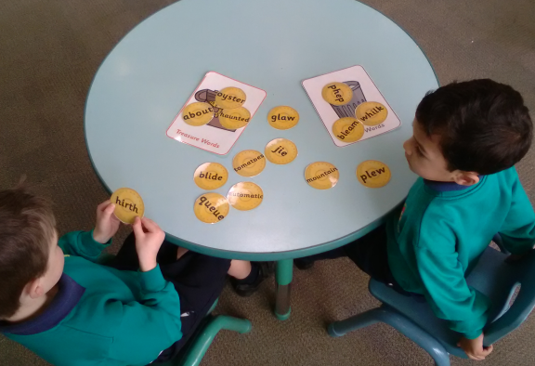
Pseudo words continue to be practised into Phase 5 using the graphemes that have been taught. Activities such as sorting real and pseudo words allow children to practise blending skills.

Phase 5 SET 3 – Year 1

Phoneme | Common Exception Words | Reading Book Sets – Example Texts
- ere, eer, ier, y, are, ear, ere, eir | don’t, old, I’m, by, time, house, your, made, came, make, here, saw, their | The Deer and the Earwig  Welcome to My Home  Wild Homes  Not in Otter’s Pocket  How Not to be Eaten  The Grasshopper and the Ants  Bella’s Bedspread  I Dare You

Phase 5 SET 4 – Year 1/2

Phoneme | Common Exception Words | Reading Book Sets – Example Texts
- y, y, s/si, a, se, se, c, g, ture, tch, dge, ge, le, ve | today, says, your, by, here, there, where, love, once, ask, friend, school, push, pull, full, house, our | Jack and the Giants  Crocs and Rocks  Little Pickle and Greedy Giant  Witney and Boscoe’s Lost and Found  Fly Secrets  Around the World  The Heroes of White Whale Lighthouse  Jake and Jen and the Sea of Sharks  Extraordinary Pets  The Hide and Seek Squirrels  Mystery Structures from the Past  A Helping Hand  Tim’s Bad Mood  Hairy Fairy  Looking After a Hamster  Vulture Culture

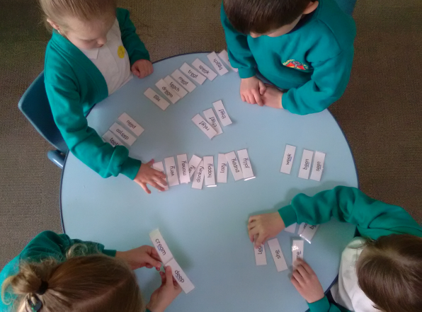

Sorting words using different graphemes for the same sound allows children to explore blending skills and spot rules for spellings.

Phase 5 SET 5 – Year 1/2

Phoneme | Common Exception Words | Reading Book Sets – Example Texts
- gn, kn, wr, mb, ti, ch, ci, sc, ce, st, ch, ch, s/ss, que | Recap all year 1 CEW and the 100 HFW | Down the Drain  Living Fossils  The Knight who could Knit  Space Science  The Great Fire of London  Reptiles Break the Rules  Nibble, Nosh and Gnasher  The Clockwork Hand  Plastic Planet  Poles Apart  The Shy Monster  What’s it made from?  Tim and Tiger  Jake and Jen in the Mission to Mars  Titanic Survivor  How to be a Magician  A Celebration on Planet Zox

By the end of Year 1, phase 5 sets 1 to 3 of graphemes will be taught and decoding will be mastered for most children, Phase 5 sets 4 and 5 will continue to be taught into year 2. For those children who still need to practise decoding or will need to retake the phonics test in year 2, then small intervention groups will be able to support the learning. Those children who pass the Year 1 phonics test and are secure in Phase 5 teaching will move onto spelling, punctuation and grammar based learning while they are in Year 2.
Whole Scheme Sound Chart
The following table shows a whole scheme sound chart of every grapheme that is covered from phase 2 to the end of phase 5.

a | e | i | o | u | ai
a | e  ea | i  y | o  a | u  o | ai  ay  a-e  ey  a  eigh

ee | igh | oa | oo | oo | ar
ee  ea  ey  e-e  ie  e  y | igh  ie  i-e  i  y | oa  oe  o-e  ow  o  ou | oo  oul  u | oo  ue  ew  u-e  ou | ar  a  al

or | ur | ow | oi | ear | air
or  aw  au  al  our  augh  ore  oor | ur  er  ir  ear  or  ere | ow  ou | oi  oy | ear  ere  eer  ier | air  are  ear  ere  eir

ure | y+oo | b | c | ch | d
ure | ue  ew  u  u-e | b | c  k  ck  ch  que | ch  tch | d

f | g | h | j | l | m
f  ff  ph | g | h | j  g  dge  ge | l  ll  ul | m  mb

n | ng | p | qu | r | s
n  gn  kn | ng | p | qu | r  wr | s  ss  c  se  sc  ce  st

sh | t | th | v | w | x
sh  ch  ti  ci  s  ss | t | th | v  ve | w  wh | x

y | z | zh | ture
y | z  zz  se | s  si | ture (ch+u)

Terminology
Phonological awareness - The ability to notice, hear and manipulate the sounds and spoken parts of the language, it is crucial to both reading and writing.

Phonemic awareness - The understanding that the sounds of spoken language work together to make words, ability to work with the individual sound or phonemes in spoken words.

Phonics - The understanding that there is a relationship between letters and sounds through written language.

Phoneme - The smallest unit of sound. There are approximately 44 phonemes in English (it depends on different accents). Phonemes can be put together to make words.
Grapheme - A way of writing down a phoneme. Graphemes can be made up from 1 letter e.g. p, 2 letters e.g. sh, 3 letters e.g. tch or 4 letters e.g. ough.
GPC - This is short for Grapheme Phoneme Correspondence. Knowing a GPC means being able to match a phoneme to a grapheme and vice versa.
Digraph - A grapheme containing two letters that makes just one sound (phoneme).
Trigraph - A grapheme containing three letters that makes just one sound (phoneme).
Quadgraph – A grapheme containing four letters that makes just one sound (phoneme).
Oral Blending - This involves hearing phonemes and being able to merge them together to make a word. Children need to develop this skill before they will be able to blend written words.
Blending- This involves looking at a written word, looking at each grapheme and using knowledge of GPCs to work out which phoneme and each grapheme represents and then merging these phonemes together to make a word. This is the basis of reading.
Oral Segmenting - This is the act hearing a whole word and then splitting it up into the phonemes that make it. Children need to develop this skill before they will be able to segment words to spell them.
Segmenting - This involves hearing a word, splitting it up into the phonemes that make it, using knowledge of GPCs to work out which graphemes represent those phonemes and then writing those graphemes down in the right order. This is the basis of spelling.
Adjacent consonants – Two or more consonants that are next to each other in a word, they each represent a different sound. They can appear at the beginning of the word e.g. stop at the end of a word e.g. bend or at the beginning and at the end of a word e.g. print.
Syllable – A single, unbroken unit of sound. Syllables join consonants and vowels to form words. Syllables can have more than one letter, however a syllable cannot have more than one sound. Syllables can have more than one consonant and more than one vowel, however the consonant(s) and vowel(s) that create the syllable cannot make more than one sound.
Polysyllabic words – Words that have more than one syllable.
Monosyllabic – Words with one syllable.
Assessment and Reporting
At the end of each phase and set the children will be assessed on pronouncing, finding, blending and segmenting each grapheme taught. Each phase and set of graphemes also have a list of common exception words to learn to read and spell which will be introduced alongside the new graphemes. The Phonics Lead has devised a new assessment that starts at phase 2 and will stay with the child until the end of phase 5 set 5. This assessment will move from EYFS to the end of year 2, mapping the incremental steps for progression in phonic knowledge and skills. It will be one document to capture the learning and also will give guidance to the set of books that matches phonic development. It is the responsibility of the class teacher to assess each child in their class using this aligned format, it is the responsibility of the adult teaching the phonics to communicate progress to the class teacher.

In circumstances where a child is not making the expected progress then the phonic teacher will need to assess if the group/level they are working at is appropriate and the extra support that is needed. Groupings are fluid and children will be able to repeat sets of graphemes as necessary, if the assessment shows that learning has not been embedded. This will also support the bottom 20% of the cohort who will have the opportunity to work in smaller groups, and can repeat and consolidate their learning. From these assessments the Key Stage 1 staff are able to offer intervention groups to recap or pre-teach graphemes that can be targeted to specific needs.
Professional Development
The whole staff training of observing experienced Key Stage 1 staff and then team teaching in summer 2021 has ensured that all staff were given the same consistent methods for teaching phonics. The Key Stage 1 teachers plan for the different phonic groups and this too ensures there is consistency and fidelity to the teaching of our phonics programme. Individualised training for some staff members is ongoing as they have joined the staff in the autumn term or as they progress through the phases and teach new sets of graphemes and their knowledge needs to be gained/increased to have a deeper understanding.
Monitoring and Review
The progress and assessment of the children will be monitored on a regular basis (every half term). Each term the Phonics Lead will ensure that the children are making the expected progress and adjust the groupings if needed. At the end of the year, the Phonics Lead will review the impact of the teaching and learning and will be able to adapt the programme as necessary. Any professional development that will be needed will be identified and scheduled for the autumn term.

Appendix 1

Below is a table of the historic data results from year 1 and 2. The last two years (2020 and 2021) have been a Trust based data collection based on an old phonics paper in the Autumn Term when the children have been in year 2. This was due to the coronavirus pandemic, home learning and closing of schools.

 | Year 1 |  |  | Year 2
Year | Pupils | National |  | Pupils | National
2017 | 77% | 81% |  | 90% | 62%
2018 | 84% | 82% |  | 75% | 61%
2019 | 88% | 82% |  | 57% | 56%
2020 | 72% | (N/A Trust directed test) |  | 55% | (N/A Trust directed test)
2021 | 75% | (N/A Trust directed test) |  | 55% | (N/A Trust directed test)
2022 | 80% | 75% |  | 58% | 89%
2023 | 81% | 79% |  | 66% | 89%
2024 | 94% | 80% |  | 71% | 89%
2025 | 81% | 80% |  | 50% | 89%

